Eclipse Web專案整合JPA
- 首先建立 Dynamic Web Project
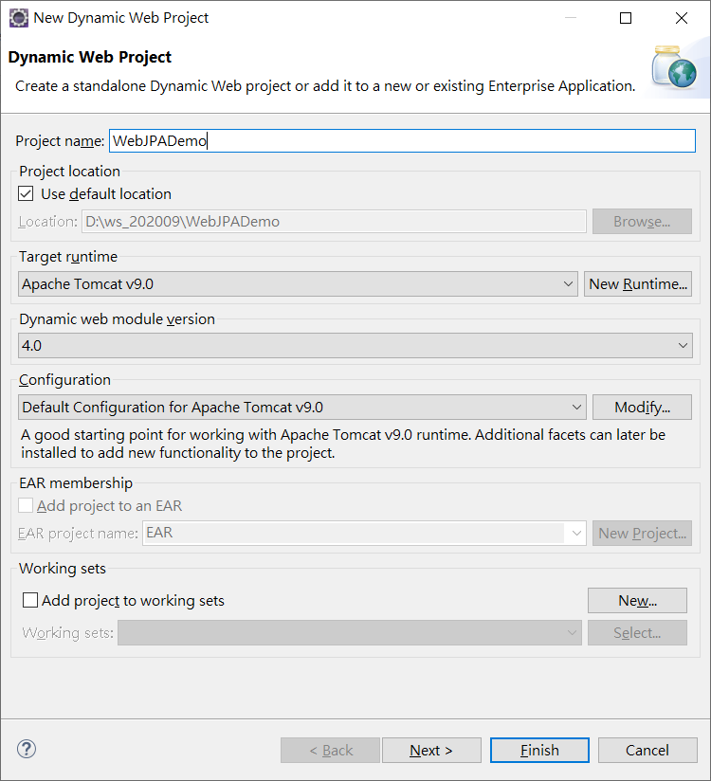
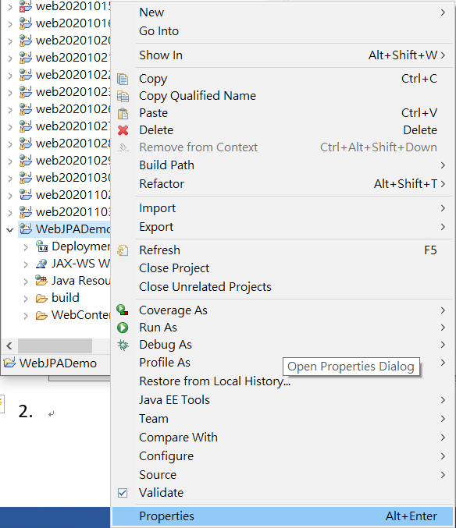
- 選擇 Project / Properties
- 選擇 Project Facets / 選擇 Further configuration available
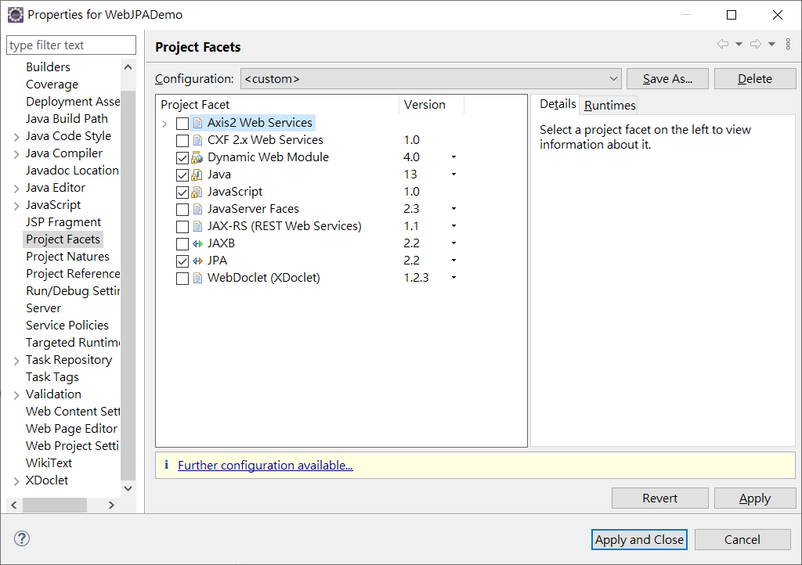
- 選擇 Connection / add driver library to build path
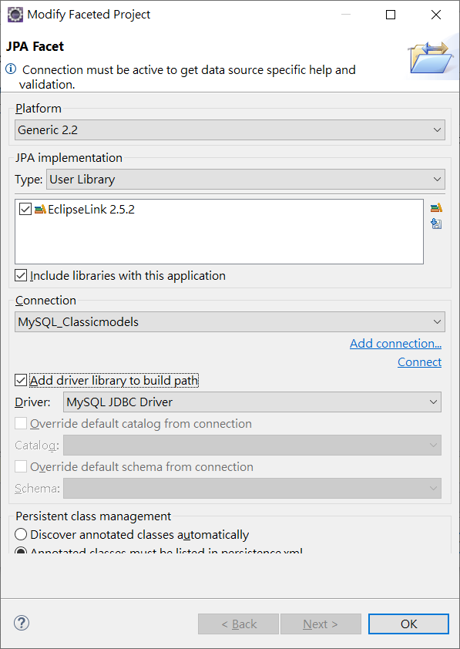
- 修改persistence.xml / Connection
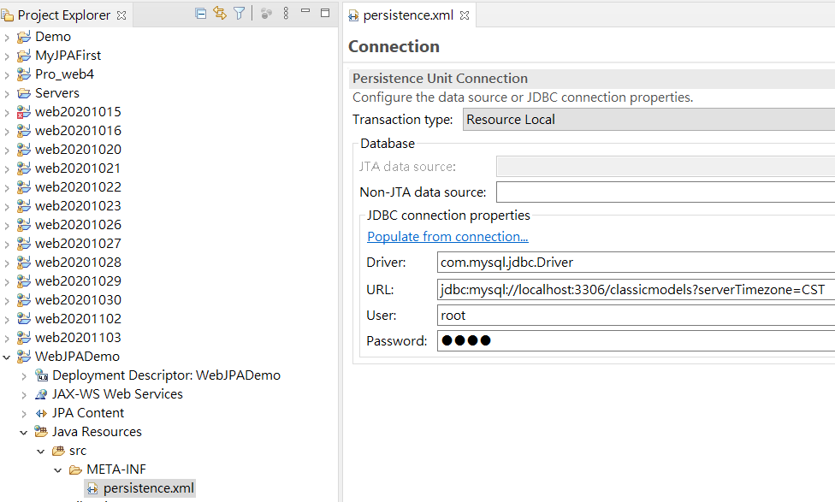
6.建立JPA映射表格類別檔案程式:
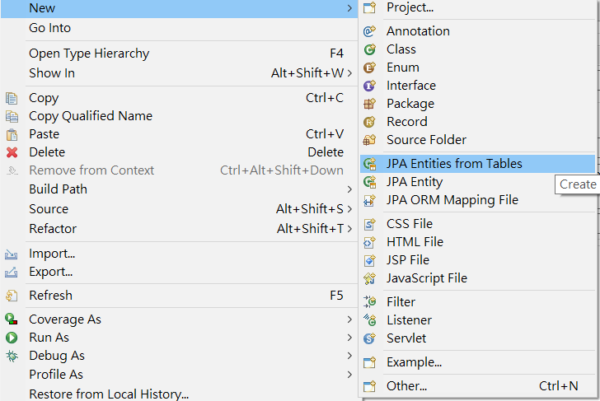
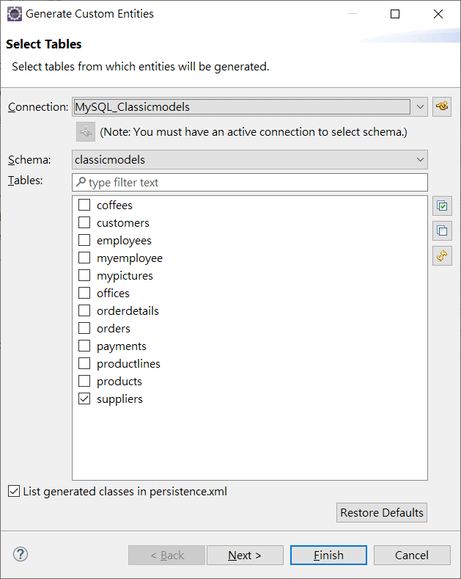
系統自行建立檔案Supplier
package model;

import java.io.Serializable;
import javax.persistence.*;
@Entity
@Table(name="suppliers")
@NamedQuery(name="Supplier.findAll", query="SELECT s FROM Supplier s")
public class Supplier implements Serializable {
private static final long serialVersionUID = 1L;

@Id
@Column(name="SUP_ID")
private int supId;

private String city;
private String state;
private String street;
@Column(name="SUP_NAME")
private String supName;
private String zip;
public Supplier() {
}

public int getSupId() {
return this.supId;
}

public void setSupId(int supId) {
this.supId = supId;
}

public String getCity() {
return this.city;
}
public void setCity(String city) {
this.city = city;
}
public String getState() {
return this.state;
}
public void setState(String state) {
this.state = state;
}

public String getStreet() {
return this.street;
}
public void setStreet(String street) {
this.street = street;
}
public String getSupName() {
return this.supName;
}
public void setSupName(String supName) {
this.supName = supName;
}
public String getZip() {
return this.zip;
}
public void setZip(String zip) {
this.zip = zip;
}

}

接下來建立 Controller 及 View 程式
import java.io.IOException;
import java.util.List;

import javax.persistence.EntityManager;
import javax.persistence.EntityManagerFactory;
import javax.persistence.Persistence;
import javax.servlet.ServletException;
import javax.servlet.annotation.WebServlet;
import javax.servlet.http.HttpServlet;
import javax.servlet.http.HttpServletRequest;
import javax.servlet.http.HttpServletResponse;

import model.Supplier;

/**
* Servlet implementation class SupplierServlet
*/
@WebServlet("/SupplierServlet")
public class SupplierServlet extends HttpServlet {
private static final long serialVersionUID = 1L;

/**
* @see HttpServlet#HttpServlet()
*/
public SupplierServlet() {
super();
}

/**
* @see HttpServlet#doGet(HttpServletRequest request, HttpServletResponse response)
*/
protected void doGet(HttpServletRequest request, HttpServletResponse response) throws ServletException, IOException {
EntityManagerFactory entityManagerFactory = Persistence.createEntityManagerFactory("WebJPADemo");
EntityManager entityManager = entityManagerFactory.createEntityManager();
entityManager.getTransaction().begin();

List<Supplier> result = entityManager.createQuery("select s from Supplier s ").getResultList();
request.setAttribute("supplier", result);
request.getRequestDispatcher("viewSupplier.jsp").forward(request, response);
entityManager.getTransaction().commit();
entityManager.close();
}

/**
* @see HttpServlet#doPost(HttpServletRequest request, HttpServletResponse response)
*/
protected void doPost(HttpServletRequest request, HttpServletResponse response) throws ServletException, IOException {
// TODO Auto-generated method stub
doGet(request, response);
}

}
View :
<%@ page language="java" contentType="text/html; charset=UTF-8"
pageEncoding="UTF-8"%>
<%@taglib prefix="c" uri="http://java.sun.com/jsp/jstl/core"%>
<!DOCTYPE html>
<html>
<head>
<meta charset="UTF-8">
<title>View Supplier</title>
</head>
<body>
<table border="1" width="70%">
<tr>
<th>Supplier ID</th>
<th>Supplier Name</th>
<th>city</th>
<th>state</th>
<th>zip</th>

</tr>
<c:forEach var="current" items="${supplier}" >
<tr>
<td><c:out value="${current.supId}" /></td>
<td><c:out value="${current.supName}" /></td>
<td><c:out value="${current.city}" /></td>
<td><c:out value="${current.state}" /></td>
<td><c:out value="${current.zip}" /></td>
</tr>
</c:forEach>
</table>
</body>
</html>
JPA的JPQL(Java Persistence Query Language)語法可類似SQL，但其查詢資料源是持久化物件(Entity)而非資料庫本身。

查詢全部因為Entity的名稱預設為實體的類別名稱，所以查詢的是Supplier類別而不是Supplier 表格。

EntityManager em = Persistence.createEntityManagerFactory("WebJPADemo ").createEntityManager();

String jpql = "SELECT s FROM Supplier s";

Query query = em.createQuery(jpql, Supplier.class);
List<Supplier> supplierList = query.getResultList();

查詢WHERE條件。後面的:supName是插入參數的位置，可以任意命名。所以下面的query.setParameter("arg1", supName);會將supName變數插入在 :arg1的位置

String jpql="select e from Supplier e where e.supName = :arg1";
Query query = entityManager.createQuery(jpql, Supplier.class);
query.setParameter("arg1", "Professional Kitchen");
List<Supplier> result = query.getResultList();

查詢WHERE...AND...。

EntityManager em = Persistence.createEntityManagerFactory("WebJPADemo ").createEntityManager();

String jpql = "SELECT e FROM Supplier e WHERE e.supName = :arg1 AND e.city = :arg2";

Query query = em.createQuery(jpql, Supplier.class);
query.setParameter("arg1", supName);
query.setParameter("arg2", city);
List<Supplier> supplierList = query.getResultList();
查詢LIKE條件

EntityManager em = Persistence.createEntityManagerFactory("WebJPADemo ").createEntityManager();

String jpql = "SELECT e FROM Supplier e WHERE e.supName LIKE :arg1";

Query query = em.createQuery(jpql, Supplier.class);
query.setParameter("arg1", "%" + supName + "%"); // e.g. %matt%
List<Supplier> supplierList = query.getResultList();

IS NULL

EntityManager em = Persistence.createEntityManagerFactory("WebJPADemo ").createEntityManager();

String jpql = "SELECT e FROM Supplier e WHERE e.supName IS NULL";

Query query = em.createQuery(jpql, Supplier.class);
List<Supplier> supplierList = query.getResultList();
建立Supplier DAO
package model;
import java.util.List;
import javax.persistence.EntityManager;
import javax.persistence.EntityManagerFactory;
import javax.persistence.Persistence;
import javax.persistence.PersistenceContext;

public class SupplierDAO {
@PersistenceContext
private EntityManager em;
public SupplierDAO() {
EntityManagerFactory emf =Persistence.createEntityManagerFactory("web20201103");
em = emf.createEntityManager();
}

public void addSupplier(Supplier sup) {
em.getTransaction().begin();
try {
em.persist(sup);
em.getTransaction().commit();
} catch (Exception e) {
e.printStackTrace();
em.getTransaction().rollback();
}

}

public void editSupplier(Supplier sup) {
em.getTransaction().begin();
try {

em.merge(sup);
em.getTransaction().commit();

} catch (Exception e) {
e.printStackTrace();
em.getTransaction().rollback();
}

}

public void deleteStudent(String id) {
Supplier student = em.find(Supplier.class, id);
em.getTransaction().begin();
try {
em.remove(student);
em.getTransaction().commit();
} catch (Exception e) {
e.printStackTrace();
em.getTransaction().rollback();
}
}
public Supplier getStudent(String id) {
return em.find(Supplier.class, id);
}
public List<Supplier> getAllStudents() {
return em.createNamedQuery("Supplier.findAll").getResultList();
}
}

import java.io.IOException;
import java.util.List;
import javax.servlet.ServletException;
import javax.servlet.annotation.WebServlet;
import javax.servlet.http.HttpServlet;
import javax.servlet.http.HttpServletRequest;
import javax.servlet.http.HttpServletResponse;

import model.Supplier;

/**
* Servlet implementation class SupplierDAOServlet
*/
@WebServlet("/SupplierDAOServlet")
public class SupplierDAOServlet extends HttpServlet {
private static final long serialVersionUID = 1L;

/**
* @see HttpServlet#HttpServlet()
*/
public SupplierDAOServlet() {
super();
// TODO Auto-generated constructor stub
}

/**
* @see HttpServlet#doGet(HttpServletRequest request, HttpServletResponse response)
*/
protected void doGet(HttpServletRequest request, HttpServletResponse response) throws ServletException, IOException {
// TODO Auto-generated method stub
model.SupplierDAO dao=new model.SupplierDAO();
List<Supplier> result = dao.getAllStudents();
request.setAttribute("supplier", result);
request.getRequestDispatcher("viewSupplier.jsp").forward(request, response);
}

/**
* @see HttpServlet#doPost(HttpServletRequest request, HttpServletResponse response)
*/
protected void doPost(HttpServletRequest request, HttpServletResponse response) throws ServletException, IOException {
// TODO Auto-generated method stub
doGet(request, response);
}

}

